|  |  |
| --- | --- |
| **Multivendor E-commerce-Mern-Learn With Project** | **Date: 04-06-2023** |

**Topics**

Multivendor E-commerce app using MERN technologies.

Frontend – ReactJS, tailwind CSS

Redux Toolkit - to manage Project State.

Backend – NodeJS, Express

Database

Socket IO – To build our chatting app and getting notification.

## **1. Project Name or Product Name**

The project name is **satty-shop.**

## **2. Project or Product Features**

Once Done list out **main feature** at here

feature

1. customer,seller login register

2. add to card

3.add to wishlist

4. customer to seller real time chat

5. product reviews

6. buy product

7. stripe payment

8.seller account active deactive

7.seller to admin real time chat and more feature

All functionalities multi vendor ecommerce

## **3. Project or Product Snapshot**

Put snapshot at here.

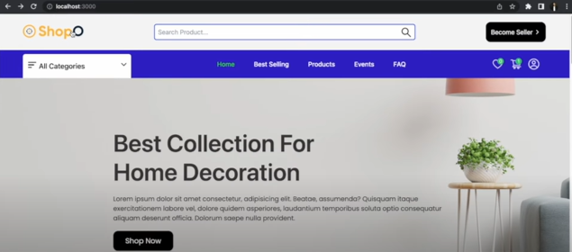

## **4. Required Software’s, tools, and packages.**

**Dashboard –**

>npm i apexcharts react-apexcharts axios jwt-decode moment react-hot-toast react-icons @reduxjs/toolkit react-redux react-spinners react-window redux-thunk socket.io-client react-router-dom

For UI Building Using Tailwind CSS - <https://tailwindcss.com/>

npm install -D tailwindcss

npx tailwindcss init

|  |  |  |
| --- | --- | --- |
| **Steps** | **Name** | **Descriptions** |
| 1 | Install any browser like [**chrome**](https://www.google.com/chrome/?brand=CHBD&brand=CHBD&gclid=CjwKCAiA5sieBhBnEiwAR9oh2lJ9VGDTO6biMtMYESBdkgSVUPw63DK5BbCKWbXxklRRhnWlgdqplxoCNXIQAvD_BwE&gclsrc=aw.ds), any editor like [**vs code**](https://code.visualstudio.com/download) | Chrome browser is used to run your application or project.  Vs code is used to write source code. |
| 2 | Install [**node js**](https://nodejs.org/en/download/) LTS version in your system  To check NodeJs is install or not, write command in cmd as  **> node -v**  Or  **> node --version**  To check npm is install in your system or not, write command as  **> npm -v**  Or,  **> npm --version** | Node and npm tool is used to create your react project and add dependencies in your project |
| 3 | Now, Go to any directory, and open your cmd in the same directory, and write command inside their as  **> npx create-react-app .** | It creates a project with the default react structures and dependencies. |
| 4 | Install Some more dependencies.   |  |  |  | | --- | --- | --- | | **SN** | **Package Name** | **Description** | | 1 |  |  | | 2 |  |  | | 3 |  |  | | 4 |  |  | | 5 |  |  | | 6 |  |  | | 7 |  |  | | |
| 5 | Now, Run your application inside the project directory by writing command in the terminal as  **> npm start** | It will start your react Project |
| 6 |  |  |

**Backend –**

>npm i nodemon mongoose dotenv bcrypt jsonwebtoken nodemailer cookie-parser express

|  |  |  |
| --- | --- | --- |
| **Steps** | **Name** | **Descriptions** |
| 1 | Install any browser like [**chrome**](https://www.google.com/chrome/?brand=CHBD&brand=CHBD&gclid=CjwKCAiA5sieBhBnEiwAR9oh2lJ9VGDTO6biMtMYESBdkgSVUPw63DK5BbCKWbXxklRRhnWlgdqplxoCNXIQAvD_BwE&gclsrc=aw.ds), any editor like [**vs code**](https://code.visualstudio.com/download) | Chrome browser is used to run your application or project.  Vs code is used to write source code. |
| 2 | Install [**node js**](https://nodejs.org/en/download/) LTS version in your system  To check NodeJs is install or not, write command in cmd as  **> node -v**  Or  **> node --version**  To check npm is install in your system or not, write command as  **> npm -v**  Or,  **> npm --version** | Node and npm tool is used to create your react project and add dependencies in your project |
| 3 | Now, Go to any directory, and open your cmd in the same directory, and write command inside their as  **> npm init.** | It creates a project with the default react structures and dependencies. |
| 4 | Install Some more dependencies.   |  |  |  | | --- | --- | --- | | **SN** | **Package Name** | **Description** | | 1 |  |  | | 2 |  |  | | 3 |  |  | | 4 |  |  | | 5 |  |  | | 6 |  |  | | 7 |  |  | | |
| 5 | Now, Run your application inside the project directory by writing command in the terminal as  **> npm start** | It will start your react Project |
| 6 |  |  |

## **5. Boot Project**

Now, Run your application inside the project directory by writing command in the terminal as

**> npm start**

## **6. Future Features Plan**

Yet not Plan.

## **7. Project Deployment**

## **8. Project Credentials**

## **9. Resources docs and links**

**Project Original Source Code -** https://github.com/SheikhFarid99/multi-vendor-ecommerce